# Overview

In this assessment, you will be tested on the skills you have learned up to this point. You can use your notes, labs, and the Internet as resources. This assessment may be timed.

# Objectives

Install and manage virtual machines in Hyper-V.

* Install Server 2019 in Hyper-V
* Configure Hyper-V storage
* Create Parent disks
* Manage VM resources

Implement a virtual infrastructure in Hyper-V using compute, storage, and networking components.

* Create differencing disks
* Create VM using differencing disk
* Create and manage switches in Hyper-V
* Connect VMs to switches in Hyper-V

# Instructions

## Setup

1. **Save or shutdown any running virtual machines.**
2. **You will be using the same VCASTLE POD as in the Guided Practice.**
3. **It is permissible to use the parent disk images created in the Guided Practice when creating differencing disk as part of this assessment.**

**Caution: Do not create a VM and attach to any image in the D:\images folder. This will break the image that is used in the Guided Practice.**

## Create Virtual Machines

1. (20 pts) Create virtual machines with the following settings:

|  |  |  |  |
| --- | --- | --- | --- |
| Settings | | |  |
| Name | **PA1-SVR-01** | **PA1-SVR-02** | **PA1-CLT-01** |
| Memory | 2GB | 1GB | 2GB |
| Generation | 2 | 2 | 2 |
| Dynamic Memory enabled | True | True | True |
| VHD Name | SVR-01-HD.vhdx (***empty***) | None | None |
| VHD Size | 150GB | None | None |

1. (10 pts) Create differencing disks with the following settings:

|  |  |  |
| --- | --- | --- |
| Settings | |  |
| Name | **SVR-02-HD.vhdx** | **CLT-01-HD.vhdx** |
| Parent Disk | D:\Images\2K19-GUI-Base.vhdx | D:\Images\W10-Base.vhdx |

1. (5 pts) Attach the **SVR-02-HD.vhdx** virtual disk you just created to **PA1-SVR-02**. Perform the initial startup of **PA1-SVR-02** and assign the administrator password as **Password1**.
2. (5 pts) Attach the **CLT-01-HD.vhdx** disk you just created to **PA1-CLT-01**. Perform the initial startup of **PA1-CLT-01**. Create the user **ecpi** with the password of **Password1** during this initial startup.
3. (10 pts) Create virtual switches with the following settings:

|  |  |  |
| --- | --- | --- |
| Settings | | |
| Name | **LAN1** | **LAN2** |
| Type | Internal | Private |

1. (10 pts) Connect the **PA1-SVR-01** and **PA1-CLT-01** virtual machine to **LAN1** and **PA1-SVR-02** to **LAN2**.
2. (10 pts) Install Windows Server Datacenter Core on **PA1-SVR-01**. Login into **PA1-SVR-01** and set the administrator password as **Pasword1**.
3. (10 pts) Use PowerShell Direct to rename the computers using the settings below.

|  |  |  |  |
| --- | --- | --- | --- |
| Settings | | |  |
| VM Name | **PA1-SVR-01** | **PA1-SVR-02** | **PA1-CLT-01** |
| Computer Name | SVR-01 | SVR-02 | CLT-01 |

1. (10 pts) List the command that you used to rename the computers below.

|  |  |
| --- | --- |
| Commands | |
| PA1-SVR-01 |  |
| PA1-SVR-02 |  |
| PA1-CLT-01 |  |

1. Download and run the Grading script. Run the grading script

Invoke-Pester -Path C:\scripts\Grade-AS-Perftest1.test.ps1 -Output Detailed

**Submission requirements**

1. **Download** the **grading** **script** from the assignment page to the **C:\Scripts** folder.
2. Check your lab by running the following command:

Invoke-Pester -Path C:\Scripts\Grade-AS-Perftest1.test.ps1 -Output Detailed

**Note**: You will see a security warning when running the script. Enter **R** to run the script.

You should not see any red in the output. Red in the PowerShell way of telling you that an error condition exists. Most of the time, the output will tell you what is wrong. If it is not obvious, contact your teacher and ask for assistance. You will be learning PowerShell during this term. **Correct** any **errors** you may have and run the script until all the output has no red. You should see the output like the images below

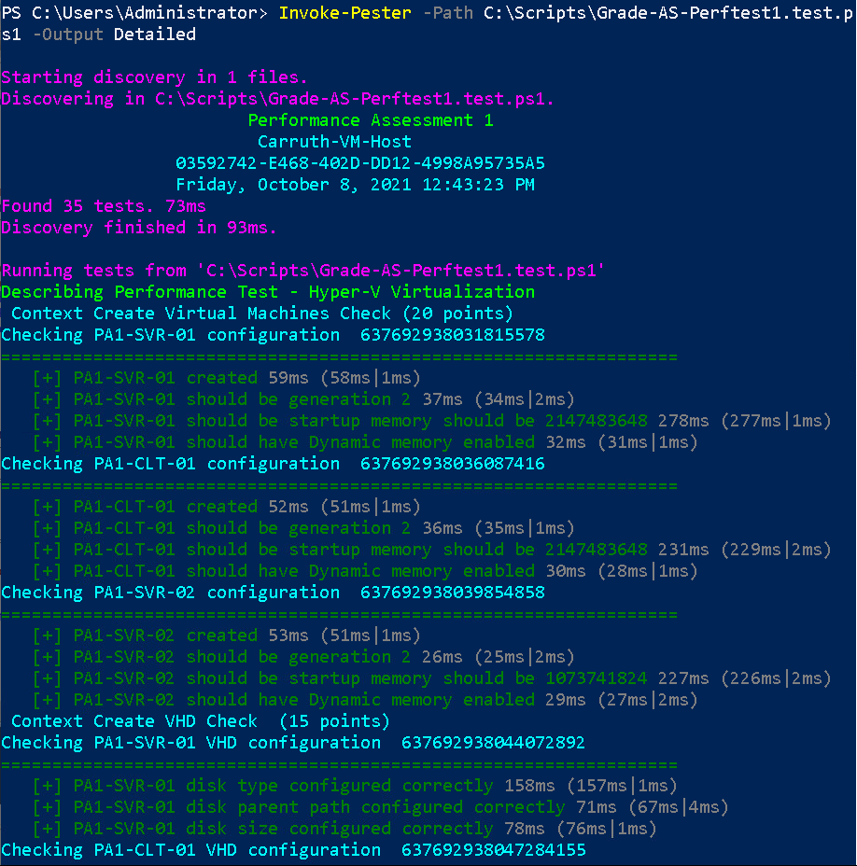

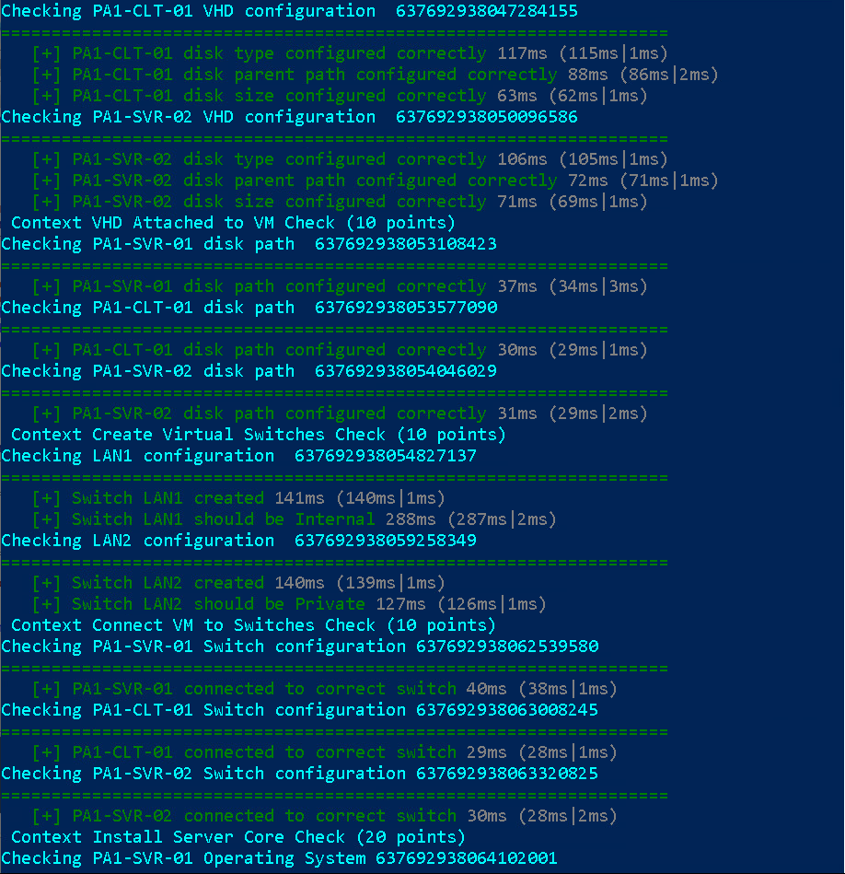

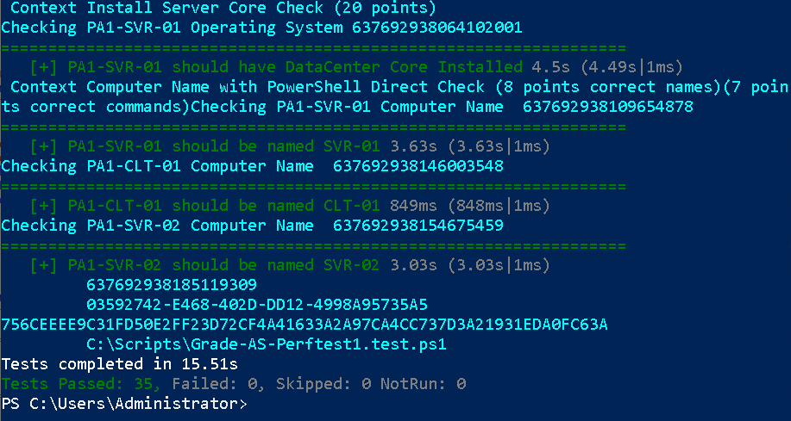

1. Create Word document named ***studentID*_PA1.docx** where ***studentID*** is your student ID. Capture a snippet that shows the PowerShell Command and all its output. If you must use more than one snippet to capture the output, you must have at least **one line of overlap** in the snippets. The command that was executed **must be at the top of the first snippet** and the **prompt after command completion must be at the bottom of the last snippet**. The characters in the snippet must be legible. Paste the snippets into the Word document named ***studentID*_PA1.docx**
2. After pasting the output of the grading script, add the PowerShell direct commands that you used to rename the computers below the grading script in Word document named ***studentID*_PA1.docx.**
3. Upload the Word document named ***studentID*_PA1.docx** in the submission area of the assignment.